Main title (22pt bolded):
Optional subtitle (22pt bolded)*

Ralph Wiggum Rebelwi Thoutacause (16pt)
Bovine University School of Hardnox (16 pt italic)

Abstract: Write an abstract of between 50 and 150 words to precede your paper. Use 12pt Times New Roman in the abstract without italicization. The entirety of the abstract should be offset from both edges of the margin by 0.3 inches. The alignment of the text should be justified to avoid a ragged right edge.

Keywords: keyword1, keyword2, keyword3, keyword4

1. Section header (16 pt bold)

The first paragraph after a header should not be indented and should be one 12pt line below the preceding header. Only capitalize the first word in the header, unless the header contains a proper noun. All body text should be 12pt Times New Roman font. Using this font and this spacing is mostly for the sake of the authors to approximate what the finished product will look like when typeset. Use a single space after a sentence break or colon. Even if you use a double space after a period, it will be automatically removed when the paper is typeset using LaTeX.
The second and subsequent paragraphs within a section should be indented and not have any additional spacing between paragraphs. All text should be single-spaced. When in doubt about any conventions, follow the Unified Style Sheet for Linguistics.

1.1. Subsection header (14pt bold)

For a subsection, do not indent the heading. All headings should be aligned to the left. Morphemic glosses should be in small caps.

- Akdiiammalapáshkuuassaaleewaachiinmook.
aku-dii-ala-balá#páshku-ua-ss-aa-dée-baa-chíili-woo-k
rel-2s-rel-wood#cut-pl.cite-goal-port-go-1a-look.for-incl-decl
‘we will look for someone to take you to Billings’ (Graczyk 2007:200)
As the example in (1) exemplifies, Leipzig Glossing Rules should be used when available. Deviations from the Leipzig Glossing Rules should be kept to a minimum. All examples should be indented. The text after the example should not be indented if it is a continuation of the previous paragraph. All morphological abbreviations should be in small caps and in 12pt font.
The translation should have a line between the last line of the interlinear glossing. Any citations for the example should appear in parenthesis after the translation in 12pt font. Per the Leipzig Glossing Rules, a hyphen (-) denotes morphological segmentation, a tilde (~) denotes reduplication, an equal sign (=) denotes a clitic, and angled brackets (<>) denote infixation. Glosses that involve multiple English words should be linked by a period (.) between each word, like in the case of ‘look.for’ in (1) above. An example of how to structure subexamples appears below.

- a. This is a subexample
b. You may use subsubexamples
i. Here is one subsubexample
ii. Do not use subsubsubexamples

A single line appears before and after the example, but not between subexamples or subsubexamples. Do not use subsubsubexamples, as they break the typesetting program with the packages that are required to typeset the proceedings.
Optimality Theory tableaux should be given their own example number with a space between the subject of the tableau. The specific look of authors’ tableaux is largely left to their discretion, so long as there is a consistent format. Similarly, it is at the authors discretion if tableaux feature shading, but be aware the all shading will be normed to light grey (Hex: BFBFBF). All constraints should be written in small caps. An example of a tableau featuring Dakota appears below.

- Tableau of /uŋ(k) + ali/ ‘we stepped over it’ from McCarthy & Prince (1993:131)

/uŋ(k) + ali/ |  |  | Onset | Root-Align | Leftmostness
a. |  | uŋ.k-a.li | * | *
b. |  | a-uŋ-.li | **! |  | a

Tableaux do not count as tables with respect to this style guide as described in §2.1 below. Some changes to the format of tableaux may change due to typesetting reasons, and the authors will be contacted about this by the editors.

1.2. Another subsection header (14pt bold)

If a subsection appears, it should be paired with at least one other subsection. That is to say, the structure of a paper should not have a section that has a single subsection within it.

1.2.1. Subsubsection header (12pt bold)

Any subsubsections will have 12pt bold Linux Libertine font in their headers.

1.2.2. Another subsubsection header (12pt bold)

Additional subdivisions within the paper will continue to have 12pt bold Linux Libertine headers.

1.2.2.1. Subsubsubsection header (12pt bold)

Authors are welcome to add whatever subdivisions they feel best makes sense for their papers.

1.2.2.2. Another subsubsubsection header (12pt bold)

You can go up to subsubsubsubsection level if you need to, but beyond that should not be used.

2. Graphics

The Times New Roman font is compatible with an enormous range of languages, and nearly all diacritics for all Siouan and Caddoan languages are able to appear with ease.

2.1. Tables

Any tables should have a centered title above, preceded by Table #. Tables should have a single line before and after them. The table itself must be centered. Unless the table is excessively large, avoid inserting a table at a place in the paper where it will cross a page break. Examples of what this should look like appear below. Err on the side of too much whitespace rather than not enough.

Table 1: Prefix field in Mandan (Kasak 2019:8)

11 | 10 | 9 | 8 | 7 | 6 | 5 | 4 | 3 | 2 | 1 | 0
rel | neg | unsp | pv.irr | 1pl | pv.ins  pv.loc  pv.refl  pv.tr | 1sg | 2sg  2pl | mid  recp  suus | incp  iter | ins | stem

Table 2: Measured means of VOT in Mandan stops (Torres 2013:29)

Stop | Number of tokens | Mean (ms) | St. Dev. (ms)
/p/ | 35 | 12.8 | 11.4
/t/ | 255 | 10.9 | 6.1
/k/ | 562 | 25.8 | 13.3

Table 3: Vowel-initial stems in Ofo (Rankin 2004:14)

 | be drowned | be stingy | say | split | sleep | be cold | stink
 | alúuthe | áakuičų | éhe | ófpəki | iiwá | ąčehí | ishúuhi
1sg | balúuthe | báakuičų | béhe | bófpəki | biiwá | bąčehí | bishúuhi
2sg | čalúuthe | čáakuičų | čéhe | čófpəki | čiiwá |  | čishúuhi
1du |  |  | ąehé
3pl |  |  | ehetú

These examples feature a top border that has a double line. It is up to the discretion of the authors whether to include other outside lines on any tables they include. When an outside line is present, it should be a single line. Internal borders are at the discretion of the authors.

2.2. Figures

All figures should likewise have a centered title above, preceded by Figure #. Figures do not need to be placed in a box, though an author may do so at their discretion. Several figures appear below as examples.

Figure 1: Final L% boundary tone in yes-no question in Lakota (Mirzayan 2010:135)

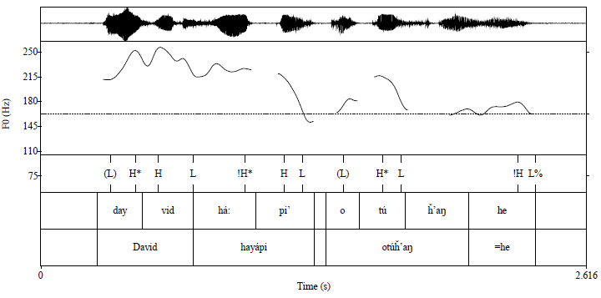
Figure 2: Hidatsa vowel duration for AW  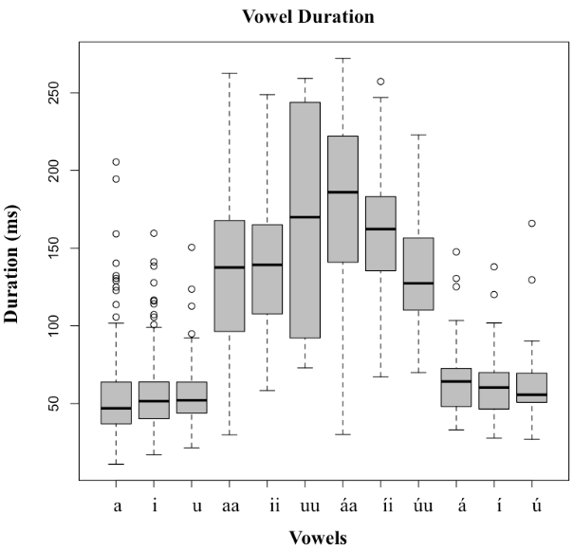 | Figure 3: Hidatsa vowel duration for MBB  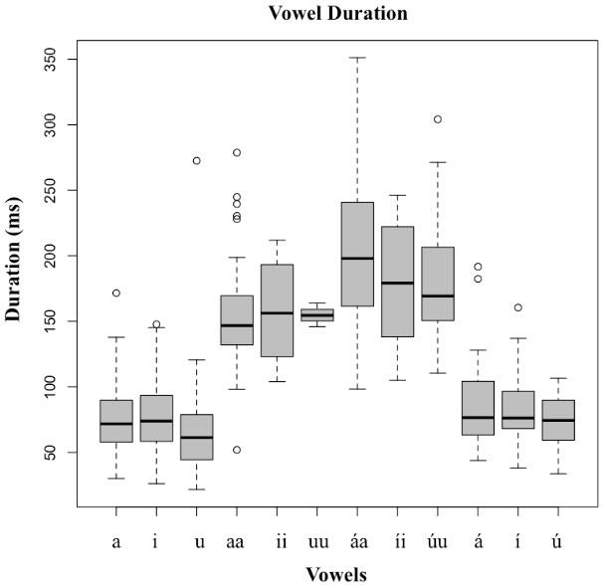

Figure 1 appears centered on the page, since it stands alone and is a rather large figure. Two figures may appear side-by-side if they are legible, as we see in the two figures from Boyle et al. (2016) in Figures 2 and 3 above.
Authors are likewise able to have blocks of more than two figures within a document: e.g., two side-by-side figures with a centered figure underneath, two rows of side-by-side figures, etc. Any figures placed in the document should be the highest quality and resolution possible, so files that are .png or .eps are recommended. Authors are invited to speak with the editor about any concerns related to figures.

3. Citing references

The Unified Sheet for Linguistics is very specific about how in-text citations and the subsequent bibliography should look.

3.1. In-text citations

All in-text citations where an author’s name is mentioned should be followed by a year in parenthesis, followed by a colon and a page number where applicable. There should be no space between the colon and the page number: e.g., According to Rankin (2004:6), Ofo has an unaspirated versus aspirated distinction for fricatives.
Conversely, when an author is being cited without their name being invoked overtly, the citation should appear at the end of the sentence or clause (i.e., before punctuation), with the last name, year, and page number held within parenthesis. There should be no comma between the author and the year: e.g., Previous work on Mandan has argued that there is a system of roots having underlying stress in Mandan (Hollow 1970:62), but more recent work shows that this perceived stress is actually due to underlying long vowels or syllables with a glottal stop coda (Kasak 2019:46).
Authors should use an ampersand to link coauthors’ names together and use ‘and’ to show a connection to differing papers: e.g., (McCarthy & Prince 1993 and Parks & Rankin 2001). The ampersand should also appear in situations where more than two authors are involved in writing a paper: e.g., Rankin, Carter & Jones (1998). Papers with fewer than three authors should include all authors in the in-text citations, but papers with more than three authors should have an “et al.” after the first author: e.g., Boyle et al. (2016) instead of Boyle, Kasak, Lundquist, Mirzayan, Torres & Williams (2016)

3.2. Bibliography

No small caps, no quotations marks (except for those overtly present in a title), no parentheses around years, and no bolded volume numbers are needed in the bibliography. Likewise, all author names should be fully written out, even if they have already been mentioned in the bibliography: i.e., do not write ____________ in the bibliography for each entry under that same author’s last name. All entries should follow the Unified Style Sheet for Linguistics. The bibliography should be in a separate section with a header labeled “References.”

References

Boyle, John P., Ryan Kasak, Sarah Lundquist, Armik Mirzayan, Jonnia Torres & Brittany Williams. 2016. A preliminary study on accentuation in Hidatsa. Paper presented at annual meeting of the Society for the Study of Indigenous Languages of the Americas. Washington, DC.

Graczyk, Randolph. 2007. A grammar of Crow. Lincoln, NE: University of Nebraska Press.

Hollow, Robert C. 1970. A Mandan dictionary. Berkeley, CA: University of California dissertation.

Kasak, Ryan M. 2019. Affix ordering and templatic morphology in Mandan. New Haven, CT: Yale University dissertation.

McCarthy, John J. & Alan Prince. 1993. Prosodic Morphology: Constraint interaction and satisfaction. In Linguistics Department Faculty Publication Series 14. Amherst, MA: University of Massachusetts, Amherst.

Mirzayan, Armik. 2010. Lakota intonation and prosody. Boulder, CO: University of Colorado dissertation.

Parks, Douglas R. & Robert L. Rankin. 2001. Siouan languages. In Raymond J. DeMallie (ed.), Handbook of North American Indians, Vol. 13 (Plains), 94-114. Washington, DC: Smithsonian Institution.

Rankin, Robert L. 2004. An Ofo grammar sketch. Ms. Lawrence, KS: University of Kansas.

Rankin, Robert L., Richard T. Carter & A. Wesley Jones. 1998. Proto-Siouan phonology and grammar. In Li, Xingzhong, Luis Lopez & Tom Stroik (eds.), Papers from the 1997 Mid-America Linguistics Conference, 366-375. Columbia, MO: University of Missouri-Columbia.

Rood, David S. & John E. Koontz. 2002. The Comparative Siouan Dictionary Project. In Frawley William, Kenneth C. Hill & Pamela Monroe (eds.), Making dictionaries: Preserving indigenous languages of the Americas, 259-281. Berkeley, CA: University of California Press.

Torres, Jonnia. 2013. An acoustic analysis of Mandan voiceless stops. Chicago, IL: Northeastern Illinois University M.A. thesis.

* This is where any thanks or acknowledgements go. Text should be 10pt Times New Roman. The first line of this or any footnote should begin 0.3 inches from the left margin and be justified to avoid a ragged right edge.
Subsequent footnotes should begin their numbering at 1. No empty space between footnotes.
If a numbered example appears in a footnote, it should be numbered with Roman numerals. - Dakȟótiyapi dakȟota#i-yA=pi Dakota#pv.ins-speak=pl ‘Dakota language’

